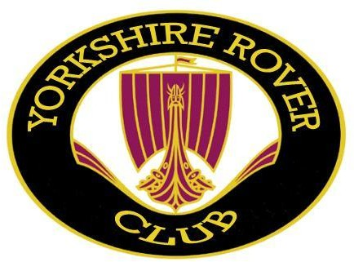
www.yorkshireroverclub.com
..
The Yorkshire Rover Club presents ’The Richard Taylor’ classic car show Sunday 7th June 2026
Oakwell Hall, Birstall, Nr Batley
(WF17 9LG)

The Yorkshire Rover Club’s 14th classic car show will be held at Oakwell Hall, Birstall, near Batley. All makes of classic cars will be welcome, but non-Rovers must be pre1985 (i.e. free road tax). This beautiful Elizabethan manor house has delighted visitors for centuries. Visiting in the 19th century, Charlotte Bronte featured it as ‘Fieldhead’. Built in 1583, the hall is now set out as it would have been in the 1690s, when it was the home of the Batt family. Set in a beautiful countryside park, where you can stroll around the delightful period garden or check out the inhabitants of the wildlife garden.
I wish to attend the above classic car show. Name:
Address:

Postcode:
Tel no (Inc code): Email:

I have read & agree to the ‘Conditions of Entry’ printed below. I enclose the show fee of £5. Cheques should be made payable to: Yorkshire Rover Club. Bank transfer: Yorkshire Rover Club, Natwest Bank, sort code 53-61-23, acct No 67756530, please use ‘Oakwell’ & your surname name as the bank transfer reference, plus important: email or text me to let me know you’ve done so.

Signature Date
Vehicle Details

Car Make: Model: Registration Number: Year:
Judging classes: There will be self-judged classes for Rover and other makes - 2 classes. Rovers of any age will be accepted, other makes of car must be pre-1985.
Please send this form & a 9in x 6in (A5) stamped addressed envelope (for return of show entry card) to: Dave Perrins, 1198 Great Horton Road, Bradford BD7 4PL email: perrinsdave@gmail.com Tel: 07772 209977
Conditions of Entry
- The show will be held from 10am to 4pm on Sunday 7th June 2026. Organizers will be on site from 9am. No vehicles onsite before 9am please, but all vehicles must be on site by 10.30am. If you have pre-booked and are not on site by 10.30am, we cannot guarantee a space will still be available.
- The show site will be clearly sign-posted from Dewsbury Road, which is the main vehicle entrance to the Hall.
- Entrants will be expected to follow ALL instructions from the show marshals regarding driving, parking & displaying of vehicles. Whilst on the show field, please keep your dog on a lead at all times & supervise any children you bring.
- Space is limited to a max of 60 cars. Closing date for entry is 31st May 2026, late entries & on the day entries are welcome, but cannot be guaranteed an entry or entry to the show field.
- Neither the Organizers, The Yorkshire Rover Club, nor Kirklees Council will be held responsible for any damage to vehicles or persons attending the show.
- All vehicles displayed must be covered by a valid motor insurance policy, covering at least third-party risks.

- By completing this form, you are agreeing to the Yorkshire Rover Club (YRC) holding your details for the purposes of administration of this show. Your details will also be used by the YRC to send you an entry form for next year’s show. Your details will not be shared with any other body or organisation.

Please note: access to Oakwell Hall by car, is recommended via Nutter Lane, off Dewsbury Road the A652. Sat Nav use (WF17 9LG)
